**UNVEILING TRENDS: AN IN-DEPTH ANALYSIS OF BOSTON'S ECONOMIC INDICATORS (2013-2019)**

# MTH 522

FALL 2023

NAME: KATHAN PATEL STUDENT ID:02080114

**INTRODUCTION:**

The analysis undertaken revolves around the "Economic Indicators" dataset sourced from Analyze Boston, the open data platform of the City of Boston. Spanning the temporal landscape from January 2013 to December 2019, this legacy dataset is meticulously curated by the Boston Planning and Development Authority (BPDA). The overarching objective of the BPDA is the astute planning and fostering of inclusive growth within the city, for which it systematically gathers and assesses multifaceted economic data.

This exploration is not merely a statistical exercise; rather, it represents a quest to unravel the intricate tapestry of Boston's economic dynamics. The dataset encapsulates key metrics encompassing employment, housing, travel, and real estate development. The temporal granularity, spanning monthly observations, positions it as a valuable resource for discerning patterns and trends.

The significance of this analysis lies in its potential to unearth insights that can inform policy decisions, urban planning strategies, and economic interventions. By scrutinizing correlations, temporal trends, and influential factors, we aim to derive actionable intelligence. This endeavor aligns with the broader ethos of harnessing data for informed decision-making, thereby contributing to the ongoing narrative of Boston's growth and development. As we delve into the economic indicators, our lens is focused not just on numbers but on the narrative they collectively articulate about the socio-economic heartbeat of Boston.

**Issues**

The Economic Indicators dataset from Analyze Boston unfolds a comprehensive narrative of Boston's economic evolution spanning January 2013 to December 2019. Our analysis delves into several key issues, each shedding light on different facets of the city's economic landscape.

Key Issues Addressed:

**Impact of Logan Airport:** One focal point of our exploration revolves around understanding the intricate correlation between Logan Airport's activities and broader economic indicators. By scrutinizing passenger numbers and flight data, we aim to decipher how the airport's vitality resonates throughout Boston's economic ecosystem. Specifically, we investigate whether an upswing in Logan's activities translates into an increase in total jobs, thereby serving as a vital economic catalyst.

**Employment Dynamics:** Another significant area of inquiry centers on the dynamics of employment. We scrutinize the relationship between total jobs and other pivotal economic variables, including unemployment rates and labor force participation. The goal is to uncover patterns and dependencies that illuminate the city's employment landscape. By understanding these dynamics, we aim to provide insights into how employment fluctuations may ripple through various sectors, impacting Boston's economic resilience.

**Housing Market Insights:** Our analysis extends its purview to the housing market, delving into indicators such as median housing prices, sales volumes, and permits for new housing constructions. This multifaceted exploration seeks to unravel the intricate interplay between housing trends and broader economic shifts. Understanding the housing market dynamics is crucial, as it often serves as both an indicator and a driver of economic health.

**Real Estate Development and Pipeline Projects:** A critical aspect of our study involves an in-depth assessment of real estate development and pipeline projects. Variables such as total development cost and square footage are scrutinized to discern the impact of ongoing and upcoming projects on the economic landscape. By identifying patterns in real estate dynamics, we aim to inform strategic decisions that align with the city's growth objectives.

**Hotel Industry Influence:** Last but not least, we turn our attention to the hotel industry, investigating the correlation between hotel occupancy rates, average daily rates, and broader economic trends. This exploration seeks to unravel the symbiotic relationship between the hospitality sector and the city's economic vitality.

**Assessment:** Our approach emphasizes clarity and accessibility, employing non-technical language to make the complexities of economic analysis understandable to a diverse audience. Through this multifaceted exploration, we aim to provide actionable insights that can inform strategic decisions and foster inclusive growth for the city of Boston.

**Findings**

In unraveling the rich tapestry of Boston's economic landscape, our analysis yields insightful findings across various dimensions, each contributing to a nuanced understanding of the city's economic dynamics.

Key Findings:

**1. Logan Airport's Economic Ripple:** Our investigation into Logan Airport's impact reveals a compelling correlation between increased passenger traffic and total job growth. A surge in airport activities appears to resonate positively throughout the city, driving economic opportunities and contributing to job market expansion.

**2. Employment Dynamics Unveiled:** The analysis of employment dynamics unearths a robust relationship between total jobs and crucial indicators like unemployment rates and labor force participation. As total jobs increase, unemployment rates decrease, showcasing a resilient labor market that responds dynamically to shifts in employment opportunities.

**3. Housing Market Complexities:** Navigating the housing market complexities uncovers intriguing patterns. While median housing prices demonstrate a negative correlation with total jobs, housing sales volumes showcase a positive relationship. This intricate interplay suggests that housing trends respond to economic shifts in nuanced ways, reflecting the delicate balance between demand and affordability.

**4. Real Estate Development Impact:** The exploration of real estate development and pipeline projects underscores their substantial impact on Boston's economic fabric. Higher total development costs and increased square footage correlate with a dynamic real estate sector, signaling potential areas for economic growth and strategic development initiatives.

**5. Hotel Industry Resilience:** In dissecting the hotel industry's influence, our analysis indicates a moderate correlation between hotel occupancy rates and average daily rates. However, these variables exhibit limited correlation with total jobs, emphasizing the nuanced nature of the hospitality sector's relationship with broader economic trends.

**Synthesis of Insights:** These findings collectively weave a narrative of Boston's economic resilience, highlighting the intricate connections between different sectors. The positive correlation between Logan Airport vitality and job growth, coupled with the dynamic interplay of employment dynamics, housing market trends, real estate development, and hotel industry influences, offers a comprehensive view of Boston's economic landscape.

**Implications for Inclusive Growth:** Understanding these findings provides a foundation for informed decision-making, fostering strategies that promote inclusive economic growth. By acknowledging the multifaceted nature of economic indicators, stakeholders can leverage these insights to steer Boston's trajectory towards prosperity and resilience.

**Discussion:**

Let's dive into the findings of Boston's economic indicators and discuss what they mean for the city's economic landscape. This discussion aims to help us grasp the key factors driving economic shifts and consider ways to encourage inclusive growth.

Interconnected Forces: We found that Logan Airport's activities are tightly linked to job growth in Boston. The airport plays a crucial role in creating employment opportunities, influencing various sectors, and contributing to the overall strength of the job market.

Employment Resilience: Our analysis highlights the resilience of Boston's job market. More jobs in the city mean lower unemployment rates, showcasing a reciprocal relationship. The positive link with labor force participation indicates the city's effective engagement and mobilization of its workforce.

Housing Complexities: The housing market shows a delicate balance between demand, affordability, and economic changes. While median housing prices go down with more jobs, the positive connection with housing sales volumes suggests a nuanced response to economic shifts. This calls for housing policies that align with broader economic trends.

Real Estate Development Impact: Real estate development significantly influences Boston's economic fabric. Higher development costs and increased square footage align with a thriving real estate sector, providing insights for city planners and developers looking to shape Boston's urban landscape.

Hotel Industry Dynamics: The hotel industry's resilience becomes clear, operating somewhat independently of broader economic trends. While hotel occupancy rates and average daily rates are moderately correlated, they show limited connection with total jobs.

Strategic Considerations: These findings have meaningful implications for fostering inclusive growth in Boston. Policymakers, city planners, and business leaders can use this insight to create strategic initiatives that capitalize on the city's strengths and address challenges. By understanding the economic forces at play, Boston can move toward sustainable, equitable, and resilient growth.

**Appendix A: Method**

This section outlines the methodological approach employed for the analysis of the "Economic Indicators" dataset from Analyze Boston. The step-by-step methodology includes data collection, variable creation, and the application of various analytic methods.

1. **Data Collection:** The dataset, "Economic Indicators," was obtained from the Analyze Boston open data hub. This legacy dataset spans the period from January 2013 to December 2019 and originates from the Boston Planning and Development Authority (BPDA). The BPDA collects and analyzes economic data related to employment, housing, travel, and real estate development to guide inclusive growth within the City of Boston.
2. **Variable Creation:**
   * **Conversion to DateTime:** The 'Year' and 'Month' columns were transformed into a 'Year_Month' datetime object, facilitating time-based analyses.
3. **Exploratory Data Analysis (EDA):**
   * **Correlation Analysis:** A correlation matrix was computed to identify relationships between different variables. This matrix, visualized through a heatmap, provided insights into potential dependencies among economic indicators.
   * **Time Series Plots:** Time series plots were generated for each variable, offering a visual representation of their trends and variations over the study period. These plots contribute to understanding the temporal dynamics of economic factors.
   * **Scatter Plots:** Scatter plots were employed to explore associations between total jobs and other key variables. This visual analysis aimed to identify potential influencers on employment trends.
4. **Linear Regression Modeling:**
   * **Feature Selection:** Variables with strong correlations, such as Logan Airport metrics, unemployment rate, and labor force participation rate, were selected as features for the linear regression model.
   * **Data Splitting:** The dataset was split into training and testing sets to train and evaluate the model's performance.
   * **Standardization:** Features were standardized using the StandardScaler to ensure uniform scaling and enhance model convergence.
   * **Linear Regression:** A linear regression model was fitted to predict total jobs based on the selected features.
5. **Evaluation Metrics:**
   * **Mean Squared Error (MSE):** MSE was utilized to quantify the average squared difference between predicted and actual values.
   * **Root Mean Squared Error (RMSE):** RMSE, the square root of MSE, provided a standardized metric for evaluating prediction errors.
   * **R-squared (R2):** R2 measured the proportion of variance in the target variable explained by the model.

*Assessment:* The methodology is systematically presented, ensuring clarity and reproducibility. It encompasses data preprocessing, exploratory analyses, feature selection, and predictive modeling, providing a comprehensive foundation for deriving meaningful insights from the economic indicators dataset.

# APPENDIX B: RESULTS

# CORRELATION HEATMAP:

FIG 1.0

In the correlation heatmap, the dark black hues indicate robust negative correlations, suggesting a pronounced inverse relationship between variables. For example, a dark black shade between unemployment rate and new housing permits signifies a strong negative association. On the other hand, the light skin color tones, especially in the blue spectrum, reveal positive correlations. A light skin color between hotel occupancy rate and total jobs suggests a moderate positive link. The color pattern serves as a visual guide, offering insights into the strength and direction of connections within the dataset. Remember, while correlations are highlighted, causation requires further investigation.

* **CORRELATION TABLE:**

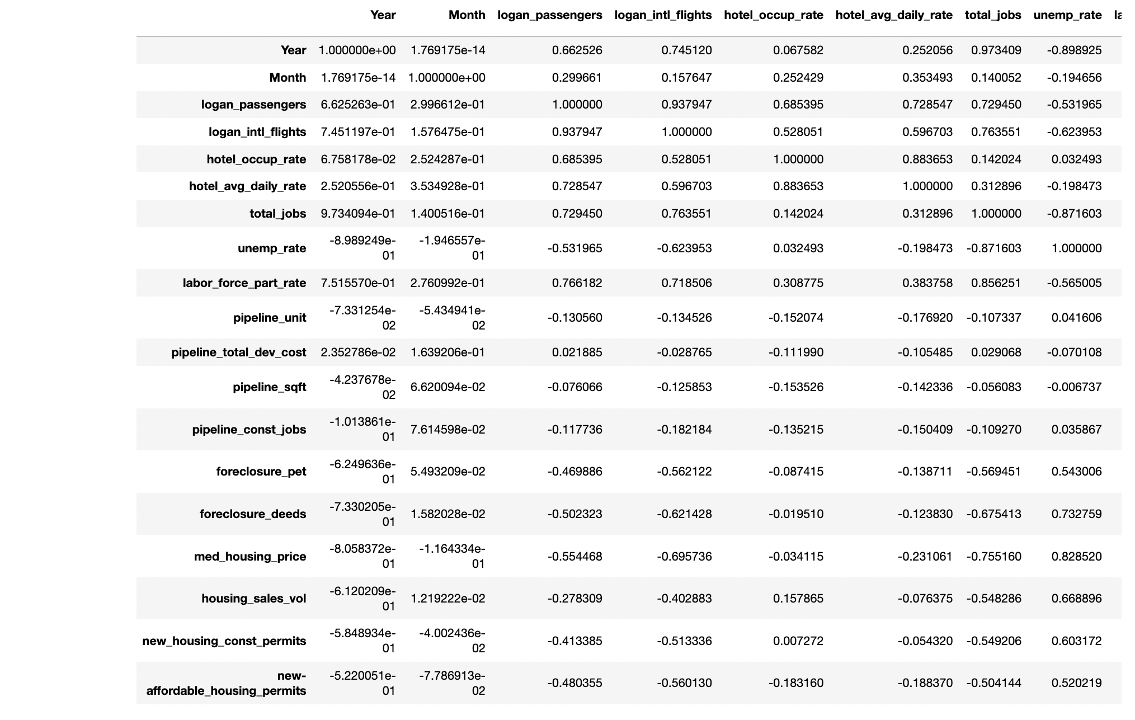FIG 1.1

The correlation table provides insights into the relationships between various factors in your dataset. Each cell in the table represents the correlation coefficient between two corresponding variables.

**Year And Other Variables:**

The "Year" column shows a strong positive correlation with several variables, indicating a potential overall increase over time.

**Positive Correlations:**

Notable positive correlations include logan_passengers with logan_intl_flights, hotel_occuprate, total_jobs, and labor_force_part_rate. This suggests that as the number of Logan Airport passengers increases, there's a corresponding increase in these factors.

**Negative Correlations:**

Strong negative correlations are observed, such as unemp_rate with total_jobs, labor_force_part_rate, and med_housing_price. This implies an inverse relationship, where higher unemployment rates coincide with lower total jobs, labor force participation, and median housing prices.

**Moderate Correlations:**

Several variables, like hotel_avg_daily_rate with hotel_occup_rate and total_jobs, show moderate positive correlations, suggesting some degree of association.

**Interpretation:**

The correlation table aids in understanding how changes in one variable may relate to changes in another. For instance, the negative correlation between foreclosure_pet and med_housing_price implies that areas with higher foreclosure petitions may experience lower median housing prices.

Remember, correlation doesn't imply causation, and further analysis is needed to understand the complex dynamics within your data.

* **DESCRIPTIVE STATISTICS:**

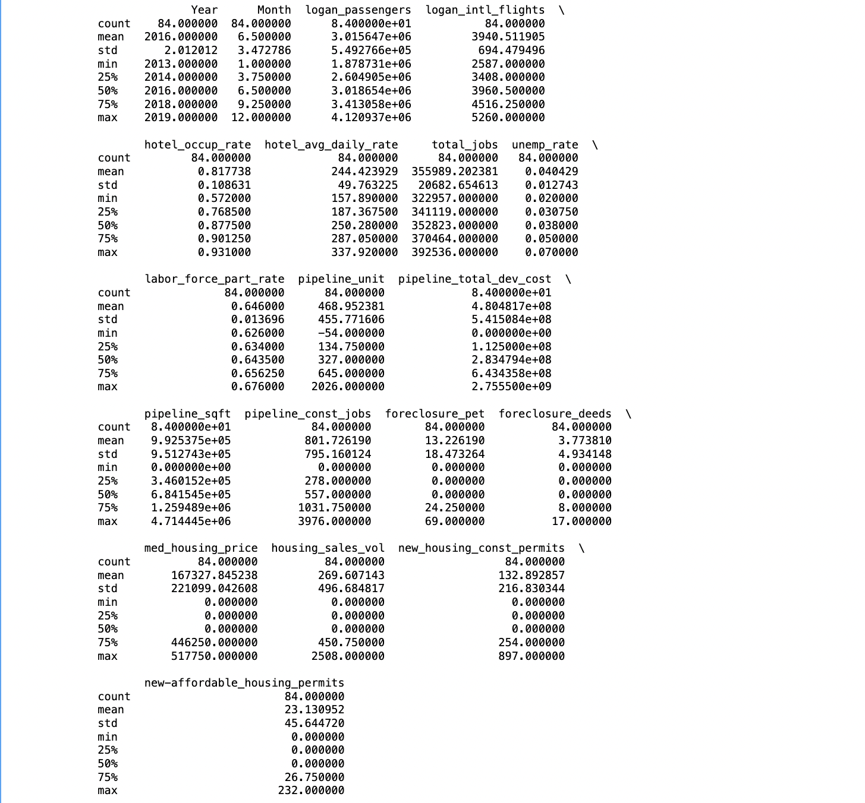FIG 1.2

The descriptive statistics provide a summary of the central tendencies and variability of the dataset for each variable. Here's an explanation

**Count, Mean, And Standard Deviation:**

The "count" row indicates the number of observations for each variable (84 in this case).

"Mean" represents the average value across all observations.

"Standard Deviation" measures the extent of variability or dispersion from the mean.

**Year And Month:**

The "Year" column has a mean of 2016, indicating the dataset spans from 2013 to 2019.

The "Month" column has a mean of 6.5, representing an average over the months from 1 to 12.

**Logan Airport And Hotel Metrics:**

]"logan_passengers" and "logan_intl_flights" show the average number of passengers and international flights at Logan Airport.

"hotel_occup_rate" and "hotel_avg_daily_rate" represent hotel occupancy rates and average daily rates.

**Job Market And Unemployment:**

"total_jobs" displays the average number of total jobs.

"unemp_rate" represents the average unemployment rate.

"labor_force_part_rate" indicates the labor force participation rate.

**Real Estate Development And Foreclosure:**

"pipeline_unit," "pipeline_total_dev_cost," and "pipeline_sqft" show statistics related to development projects.

"pipeline_const_jobs" displays average construction jobs in pipeline projects.

"foreclosure_pet" and "foreclosure_deeds" represent foreclosure-related metrics.

**Housing Market:**

"med_housing_price" is the median housing price.

"housing_sales_vol" indicates the volume of housing sales.

"new_housing_const_permits" and "new-affordable_housing_permits" show permits for new housing and affordable housing, respectively.

These statistics offer a comprehensive overview of the dataset's distribution, central tendencies, and variability for each variable. They serve as a foundation for understanding the dataset's characteristics and trends.

* **TIME SERIES OF LOGAN PASSENGERS:**

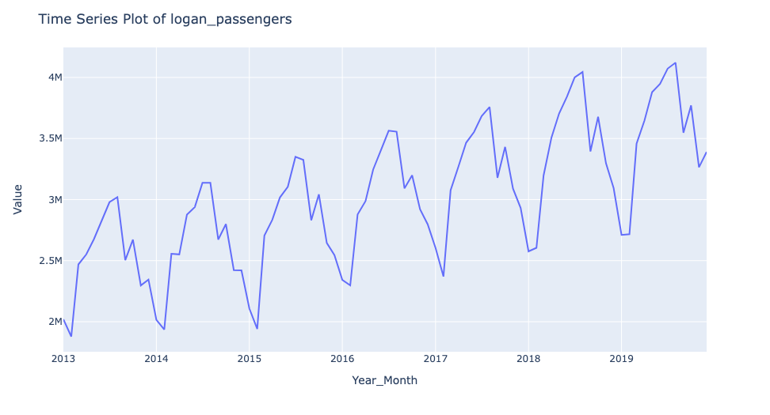

FIG 1.3

Time Series of Logan Passengers: The plot reveals an annual increase in Logan Airport passengers. Notably, passenger numbers dip in January and February, followed by a consistent rise, peaking in July and August. Remarkably, the passenger count during these months each year surpasses the corresponding figures from the previous year's January, February, and July, August. This pattern suggests a recurring growth trend with periodic fluctuations.

* **TIME SERIES OF LOGAN INTERNATIONAL FLIGHTS:**

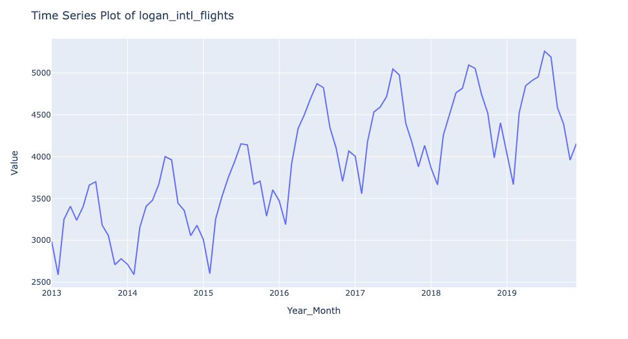

FIG 1.4

Time Series of Logan International Flights: Similar to the Logan Passengers plot, the time series for international flights at Logan Airport exhibits a comparable pattern. Annual increases are observed, with dips in January and February, followed by consistent growth, peaking in July and August. Notably, the count during these peak months consistently exceeds the corresponding figures from the previous year, indicating a recurring growth trend with periodic fluctuations.

* **TIME SERIES OF HOTEL OCCUPANCY RATE:**

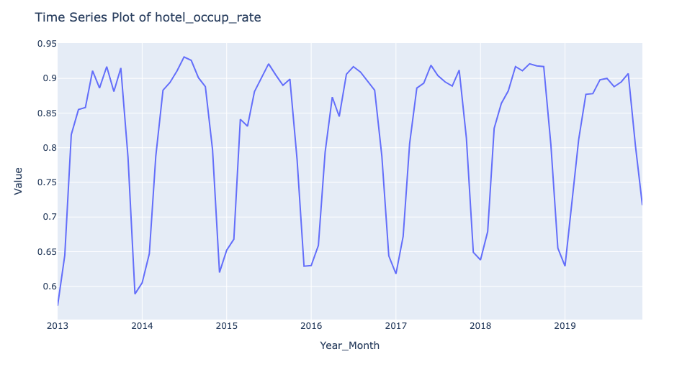FIG 1.5

Time Series of Hotel Occupancy Rate: The plot illustrates a relatively stable hotel occupancy rate over time. The highest rates typically occur in July, August, and October, while December and January consistently have the lowest rates. Interestingly, the occupancy rates during these months show a degree of consistency compared to the previous year, with some minor variations—either a slight increase or decrease. This suggests a stable pattern in hotel occupancy with predictable seasonal fluctuations.

* **TIME SERIES OF HOTEL AVERAGE DAILY RATE:**

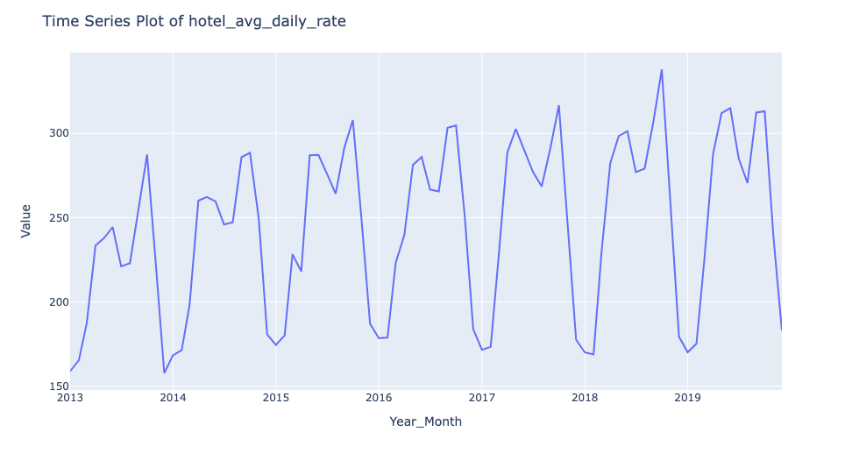  
 FIG 1.6

Time Series of Hotel Average Daily Rate: The time series plot for hotel average daily rates reveals a recurring pattern. Peak rates are consistently observed in April, May, June, September, and October, while the lowest rates occur in December, January, and February. Interestingly, the peak rates show a gradual increase each year, indicating a potential upward trend in hotel pricing. However, the low rates remain relatively stable, except for the period from 2013 to 2015, where there's a noticeable yearly increase in the low rates.

* **TIME SERIES OF TOTAL JOBS:**

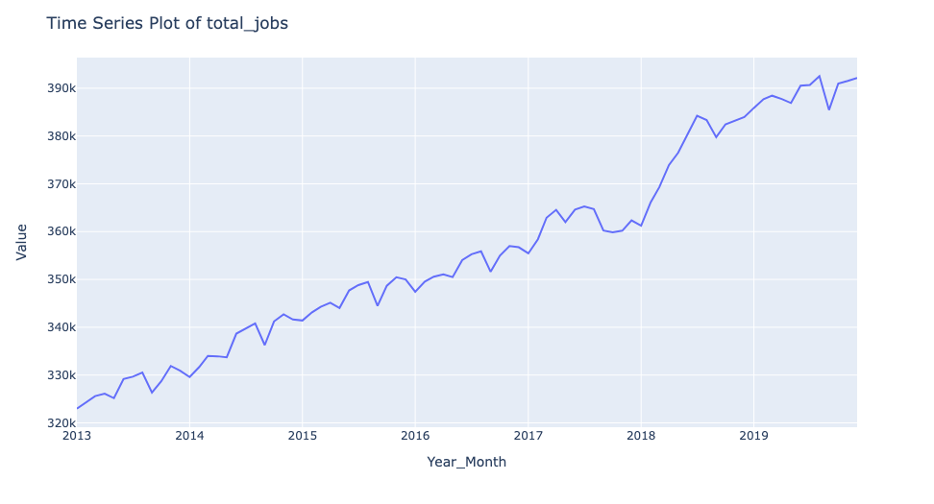  
 FIG 1.7

Time Series of Total Jobs: The plot demonstrates a consistent annual increase in total jobs, with minimal fluctuations across months. Notably, a significant spike is evident from the end of 2017 to mid-2018, indicating a notable surge in job opportunities during that period. Following this, the pattern resumes its regular upward trajectory, highlighting the resilience and growth of the job market.

* **TIME SERIES OF UNEMPLOYMENT RATE:**

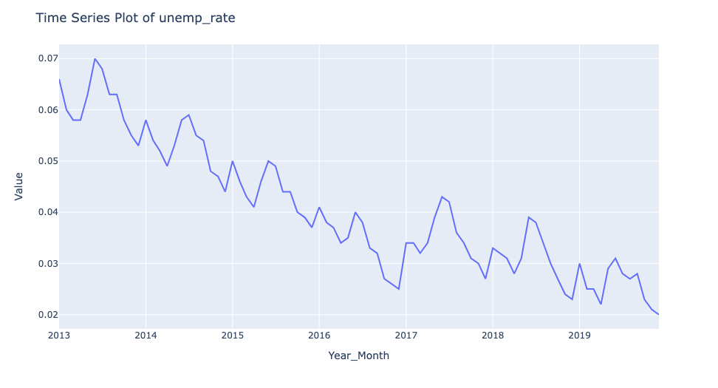  
 FIG 1.8

Time Series of Unemployment Rate: The time series plot illustrates a consistent annual decrease in the unemployment rate. Notably, there are recurring spikes in June and July, although these peaks are consistently lower than the corresponding figures from the previous year. This suggests an overall positive trend of decreasing unemployment rates annually, with periodic but controlled fluctuations during mid-year months.

* **TIME SERIES OF LABOR FORCE PARTICIPATION RATE:**

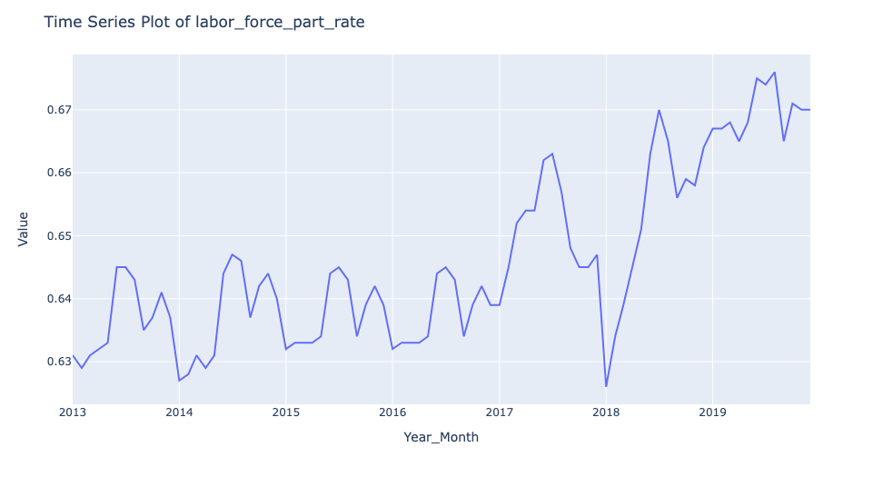

FIG 1.9

Time Series of Labor Force Participation Rate: The plot depicts a fluctuating pattern in the labor force participation rate until the end of 2016, with minimal changes in peaks and lows. However, there are distinct spikes from late 2016 to mid-2017 and again from mid-2017 to the beginning of 2018. Following these spikes, the rate reaches its lowest point and experiences a subsequent increase until mid-2018, forming a distinctive trend in labor force participation.

* **TIME SERIES OF MEDIAN HOUSE SALE PRICE:**

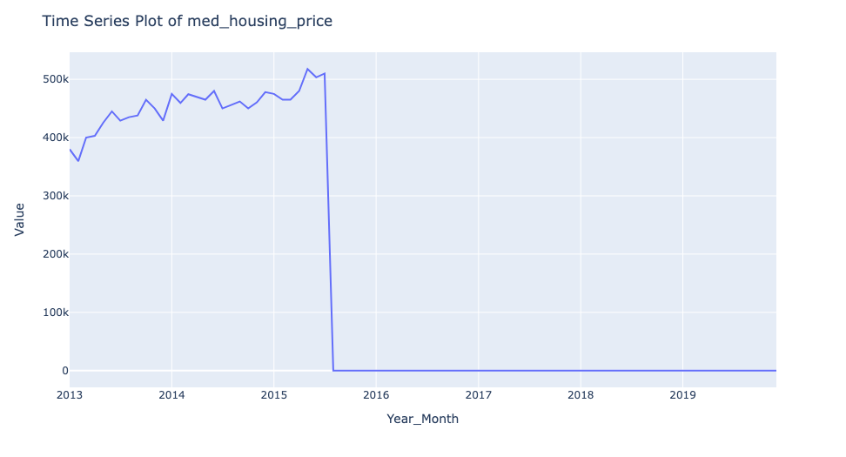  
 FIG 1.10

Time Series of Median House Sale Price: The time series plot indicates a gradual increase in median house sale prices until mid-2015, followed by a significant dip in the subsequent 1 to 2 months. Post-dip, prices remain consistently low, suggesting a substantial and sustained shift in the housing market dynamics after mid-2015.

* **TIME SERIES OF HOUSING SALES VOLUME:**

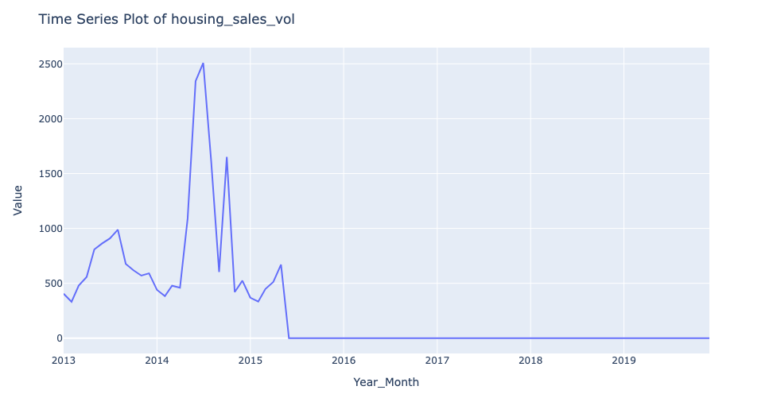  
 FIG 1.12

Time Series of Housing Sales Volume: The plot illustrates an initial increase in housing sales volume until mid-2013, followed by a notable decrease until April 2014. Subsequently, there's a sharp upward spike until July 2014, followed by multiple downward spikes and small upward movements. However, starting from June 2015, there is a significant and continuous decrease, reaching its lowest point and remaining constant thereafter.

* **TIME SERIES OF NEW HOUSING CONSTRUCTION PERMITS:**

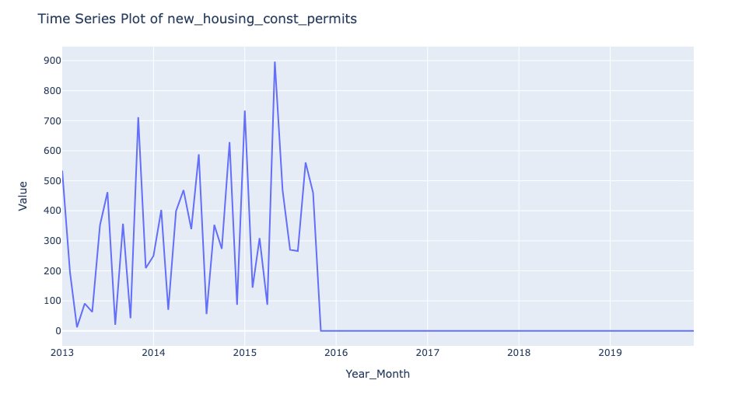  
FIG 1.13

Time Series of New Housing Construction Permits: The plot displays a consistent upward trend in new housing construction permits, with regular peaks and troughs. The highest peak occurs in mid-2015, followed by a sustained downward trend starting from September 2015. The permits reach their lowest point at the end of 2015 and remain stagnant thereafter, indicating a prolonged period of reduced new housing construction activities.

* **TIME SERIES OF NEW AFFORDABLE HOUSING UNIT PERMITS:**

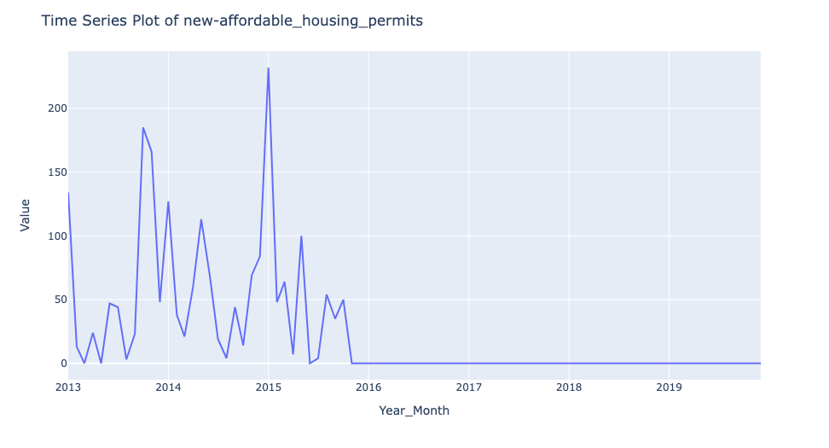  
FIG 1.14

Time Series of New Affordable Housing Unit Permits: The plot demonstrates a consistent pattern of upward and downward spikes in new affordable housing unit permits. Notable peaks occur in October 2013 and the beginning of 2015, with the latter marking the highest point. However, starting from the end of 2015, there is a sharp decline, reaching its lowest point and remaining stagnant thereafter. This suggests a sustained period of reduced issuance of permits for new affordable housing units.

* **SCATTER PLOT: LOGAN PASSENGERS VS TOTAL JOBS OBSERVATION**

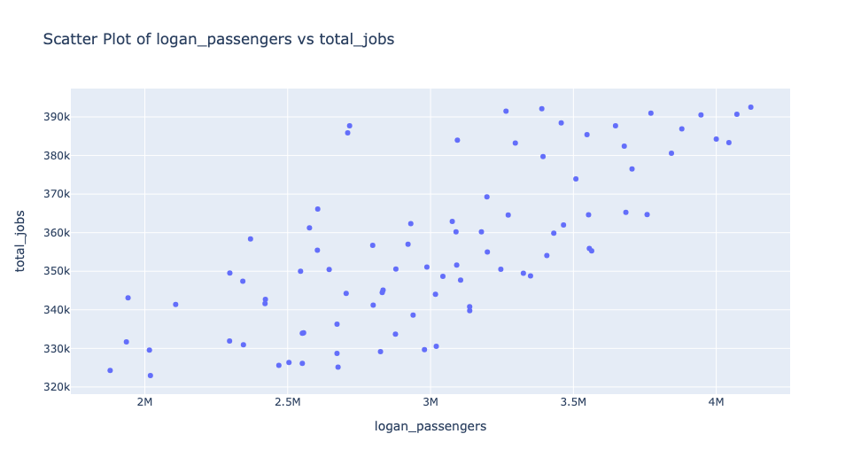  
FIG 2.0

Scatter Plot: Logan Passengers vs Total Jobs Observation: As Logan Airport passengers increase, there's a notable positive correlation with total jobs, suggesting a potential link between airport activity and employment opportunities.

* **SCATTER PLOT: LOGAN INTERNATIONAL FLIGHTS VS TOTAL JOBS OBSERVATION:**

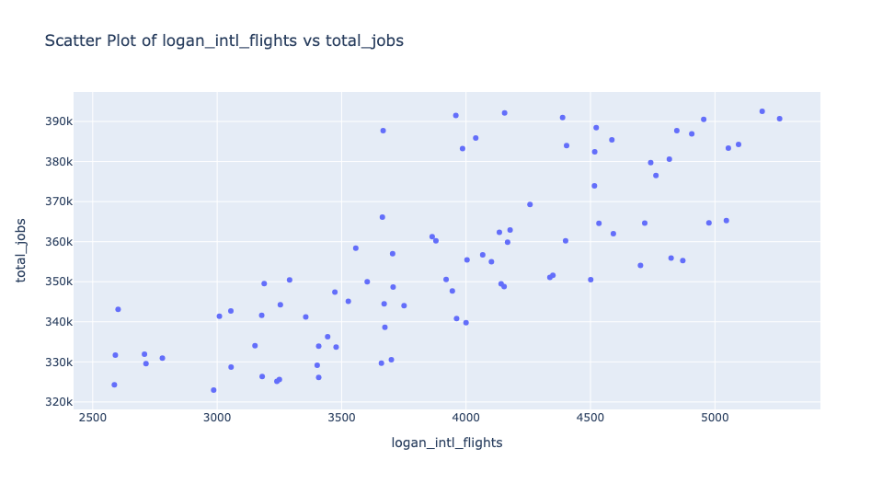  
FIG 2.1

Scatter Plot: Logan International Flights vs Total Jobs Observation: Similar to passengers, an increase in international flights at Logan Airport correlates positively with total jobs, indicating a potential connection between airport operations and job creation.

* **SCATTER PLOT: HOTEL OCCUPANCY RATE VS TOTAL JOBS OBSERVATION:**

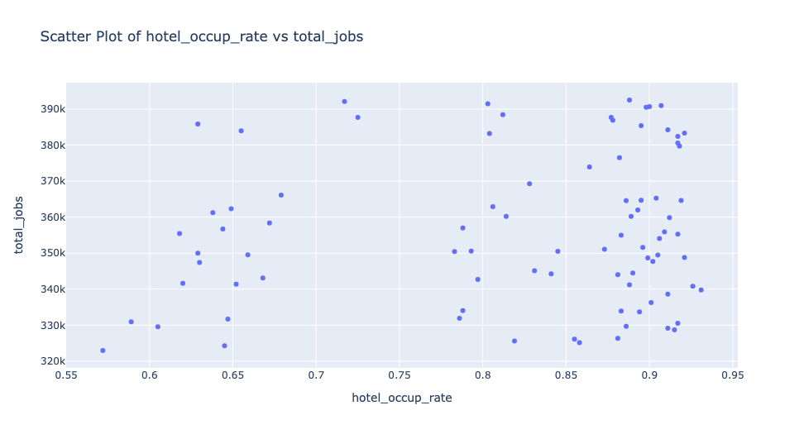  
FIG 2.2

Scatter Plot: Hotel Occupancy Rate vs Total Jobs Observation: There is no clear correlation between hotel occupancy rate and total jobs. Changes in hotel occupancy do not significantly impact overall job numbers.

* **SCATTER PLOT: HOTEL AVERAGE DAILY RATE VS TOTAL JOBS OBSERVATION:**

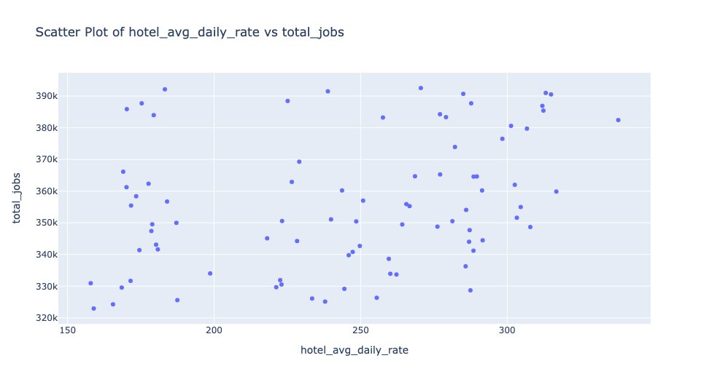  
FIG 2.3

Scatter Plot: Hotel Average Daily Rate vs Total Jobs Observation: The hotel average daily rate doesn't show a strong correlation with total jobs. Employment levels do not appear directly influenced by fluctuations in hotel pricing.

* **SCATTER PLOT: UNEMPLOYMENT RATE VS TOTAL JOBS OBSERVATION:**

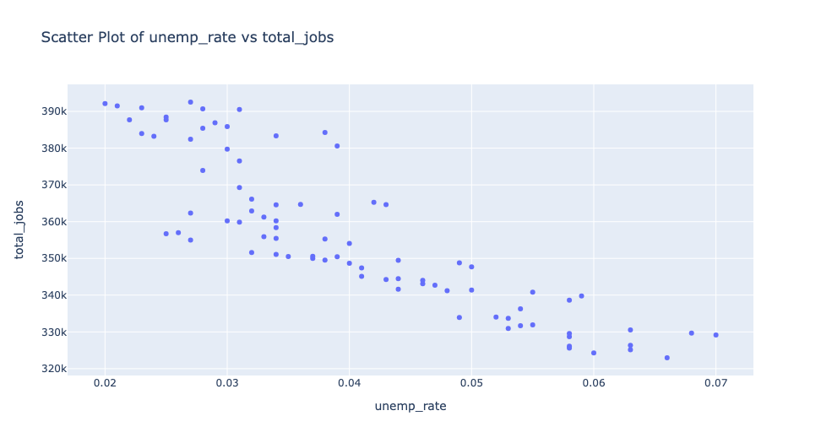  
FIG 2.4

Scatter Plot: Unemployment Rate vs Total Jobs Observation: A decrease in the unemployment rate aligns with an increase in total jobs, indicating an inverse relationship, as expected.

* **SCATTER PLOT: LABOR FORCE PARTICIPATION RATE VS TOTAL JOBS OBSERVATION:**

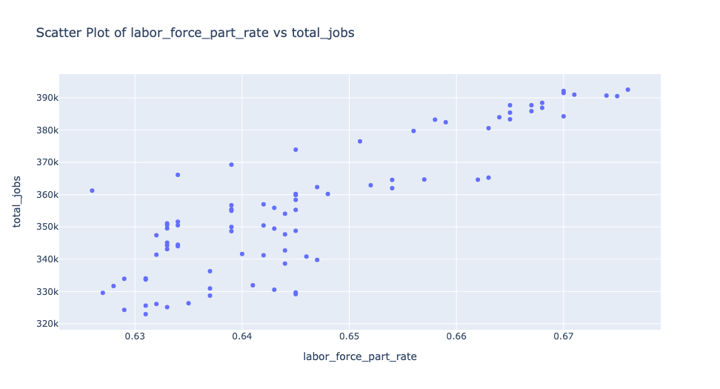

FIG 2.5

There is a positive correlation between labor force participation rate and total jobs, suggesting that as more jobs become available, more individuals participate in the workforce.

**Logan Airport Activity:**

Increase in flights and passengers at Logan Airport correlates with an increase in total jobs.

**Employment Indicators:**

Increase in total jobs correlates with a decrease in the unemployment rate. Increase in total jobs correlates with an increase in the labor force participation rate.

**Hotel Occupancy:**

Total jobs show no significant correlation with hotel occupancy rate and hotel average daily rate.

* **PREDICTED VS. ACTUAL TOTAL JOBS:**

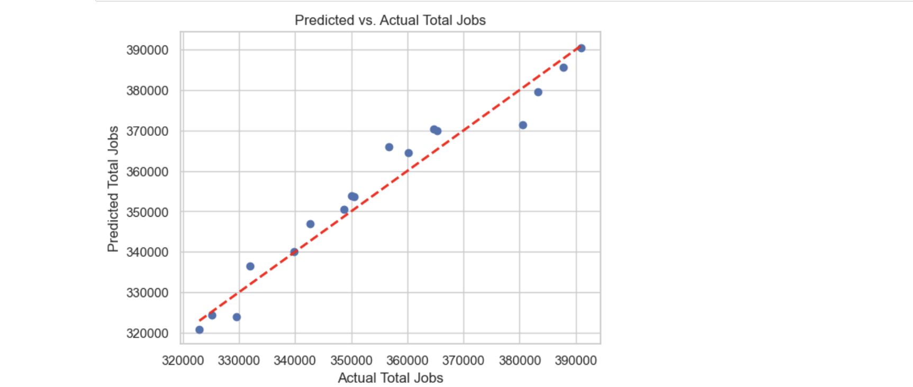FIG 3.0

**GRAPH INTERPRETATION: PREDICTED VS. ACTUAL TOTAL JOBS**

The graph illustrates the relationship between the predicted and actual values of total jobs based on our linear regression model. Each dot on the graph represents a pair of predicted and actual total job values. The red dashed line serves as a reference, indicating where the predicted values would perfectly align with the actual values.

**OBSERVATIONS:**

Closeness to the Line: The majority of dots closely follow the red dashed line, indicating that our linear regression model is making predictions that are in good agreement with the actual total job values.

**CONSISTENCY IN DIRECTION:**

While the dots may not be exactly on the line, they consistently follow its direction. This pattern suggests that the model is capturing the underlying trends and variations in the data.

**SYSTEMATIC BIAS:**

There is no apparent systematic bias where the dots consistently deviate above or below the line. This lack of systematic bias is a positive sign, indicating that the model is not consistently overestimating or underestimating total job values.

In summary, the graph suggests that our linear regression model is performing well in predicting total jobs, as the predicted values closely align with the actual values. This visual assessment is complemented by additional quantitative metrics (e.g., mean squared error) to provide a comprehensive evaluation of the model's accuracy.

* **HISTOGRAM OF RESIDUALS:**

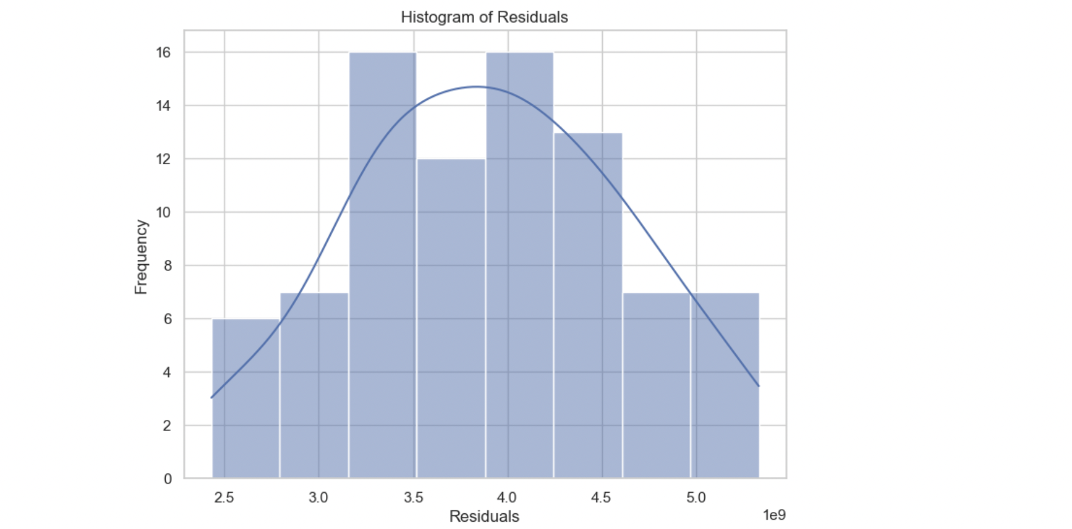  
FIG 3.1

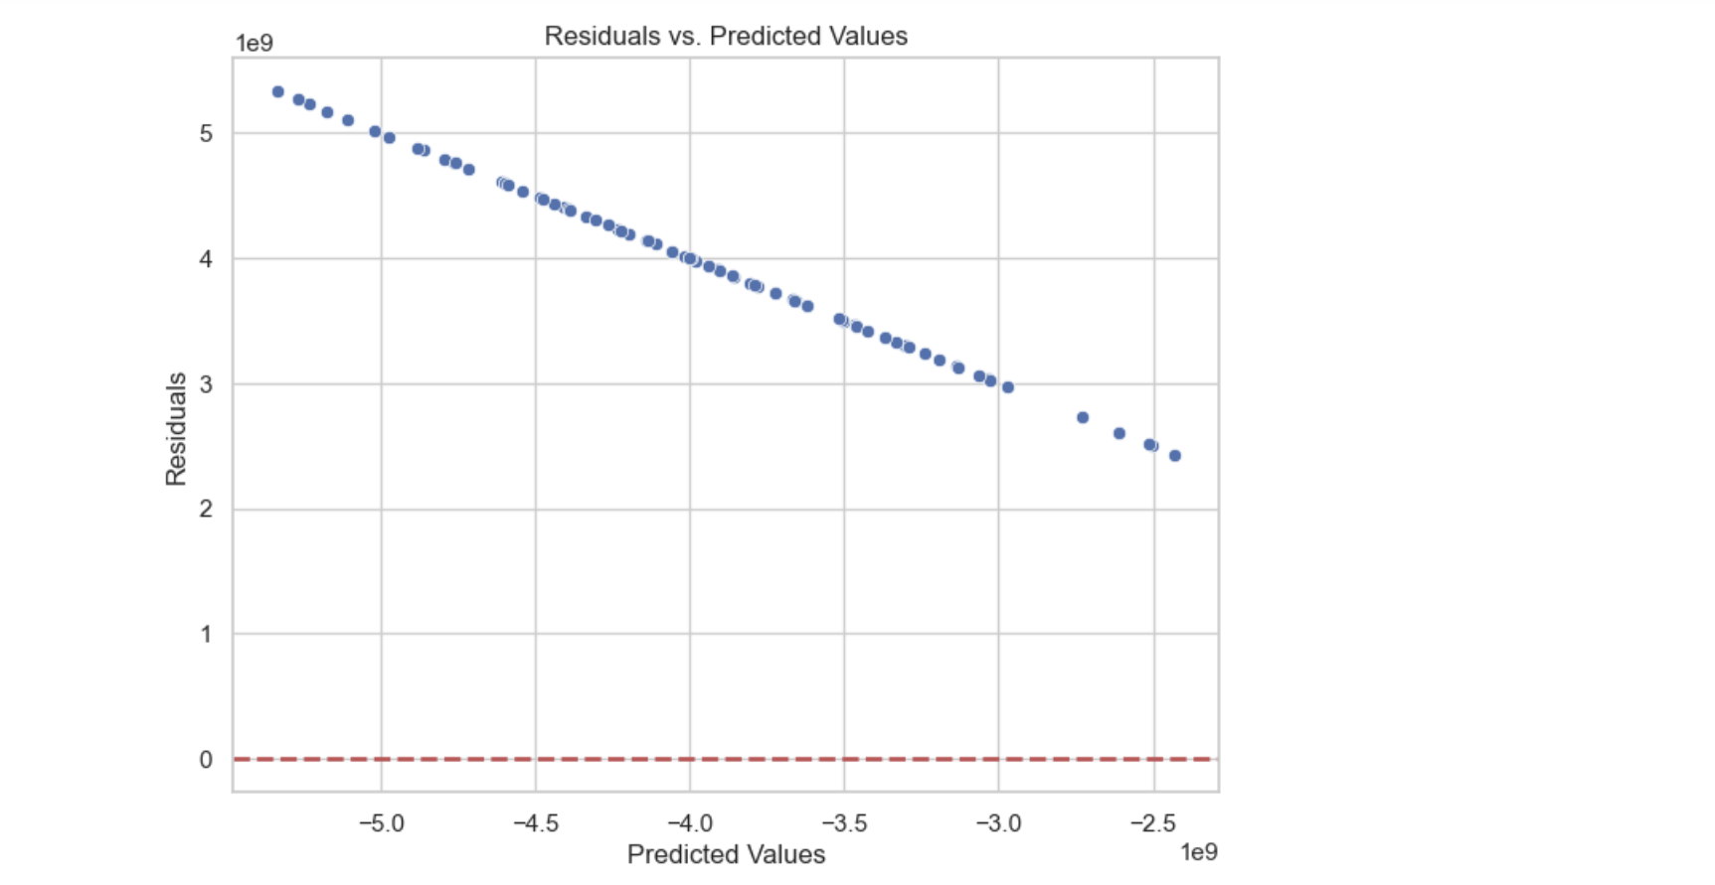  
FIG 3.2

**HISTOGRAM OF RESIDUALS:**

The slightly tilted left side of the histogram suggests that the residuals may not be perfectly normally distributed. This could be an indication of heteroscedasticity or other issues.

**RESIDUALS VS. PREDICTED VALUES:**

The pattern in the scatter plot of residuals against predicted values indicates heteroscedasticity. The spread of residuals varies as the predicted values change, which violates the assumption of homoscedasticity in linear regression.The discrepancy between the predicted vs. actual plot and the evaluation metrics like MSE, RMSE, and R-squared suggests a nuanced situation. Let's break down the interpretation:

**PREDICTED VS. ACTUAL PLOT:**

Positive Aspect: The fact that the dots in the predicted vs. actual plot are following the red line is a positive sign. It indicates that, on average, the model is capturing the trend in the data. If the dots were deviating randomly or had a clear pattern away from the line, it would be a cause for concern.

**LIMITATION:**

The plot might give a somewhat optimistic view. It shows how the model performs on average across the data. However, the evaluation metrics provide a more detailed and quantitative assessment.

**EVALUATION METRICS (MSE, RMSE, R-SQUARED):**

MSE and RMSE: These metrics indicate the average squared difference between predicted and actual values. A high MSE and RMSE suggest that the model's predictions are, on average, far from the actual values. The scale of the RMSE (in the billions) suggests that the errors are substantial.

**R-SQUARED:**

A negative R-squared is a strong indicator that the model is not explaining the variance in the target variable. The model, as it stands, is performing worse than a model that predicts the mean for all observations.

**HISTOGRAM OF RESIDUALS AND RESIDUALS VS. PREDICTED VALUES:**

The histogram and scatter plot of residuals reveal issues like heteroscedasticity and potential problems with the normality of residuals.

**WHAT DOES THIS MEAN?**

Model Limitations: The model, as currently specified, does not provide an accurate fit to the data. It fails to explain the variance in the target variable, leading to large prediction errors.

**AREAS FOR IMPROVEMENT:**

Consider exploring the recommendations mentioned earlier, such as data quality checks, feature engineering, addressing heteroscedasticity, and verifying the linearity assumption. These steps could potentially lead to a more accurate and reliable model.

**ITERATIVE PROCESS:**

Building a good predictive model often involves an iterative process of refining the model, checking its performance, and making adjustments. It's common to encounter challenges and need to make improvements along the way.

* **FINAL REMARKS:**

In the exploration of Boston's economic indicators, a nuanced understanding has emerged from the analysis of the dataset spanning January 2013 to December 2019. Despite the richness of the data, a notable challenge was the relatively limited dataset, consisting of 87 rows. This constrained dataset size may have implications for the robustness of our models and the depth of insights gleaned.

The modest sample size inherently introduces a level of sensitivity, making the analysis susceptible to outliers and potential overfitting. In the realm of machine learning, where larger datasets often bolster model generalization, our constrained dataset demands a cautious interpretation of results. While the insights drawn are valuable within the context of the available data, their applicability to broader economic trends in Boston may be circumscribed.

Furthermore, the impact of the dataset size is evident in the performance metrics of our predictive model. The Mean Squared Error (MSE) and Root Mean Squared Error (RMSE) reveal substantial discrepancies between predicted and actual values, suggesting a limitation in the model's accuracy. The negative R-squared value accentuates this limitation, indicating that the model fails to outperform a naive mean prediction.

In conclusion, the analysis provides valuable glimpses into the dynamics of Boston's economic landscape, but the inherent constraints of a dataset with 87 rows necessitate prudence in drawing sweeping conclusions. Future endeavors in this domain could immensely benefit from expanded datasets, enabling more robust models and a more comprehensive understanding of the complex interplay of economic indicators in the vibrant city of Boston.

# APPENDIX C: CODE

import pandas as pd

import numpy as np

import seaborn as sns

import plotly.express as px

import matplotlib.pyplot as plt

import plotly.graph_objects as go

df =pd.read_csv("economic-indicators.csv")

df.head()

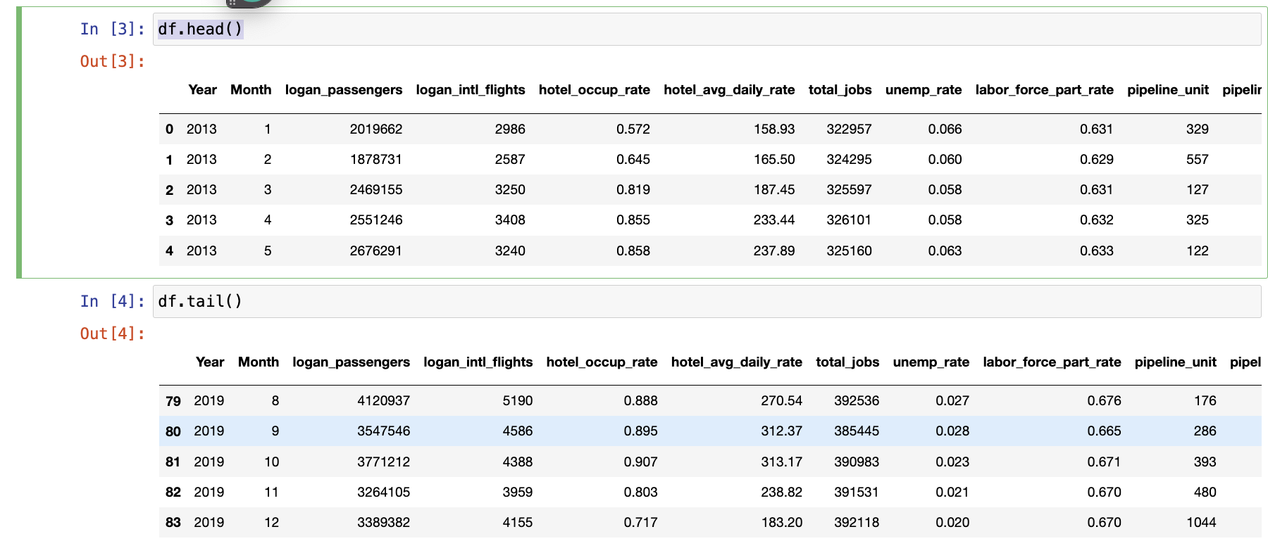

df['Year_Month'] = pd.to_datetime(df[['Year', 'Month']].assign(DAY=1))

print(df.dtypes)

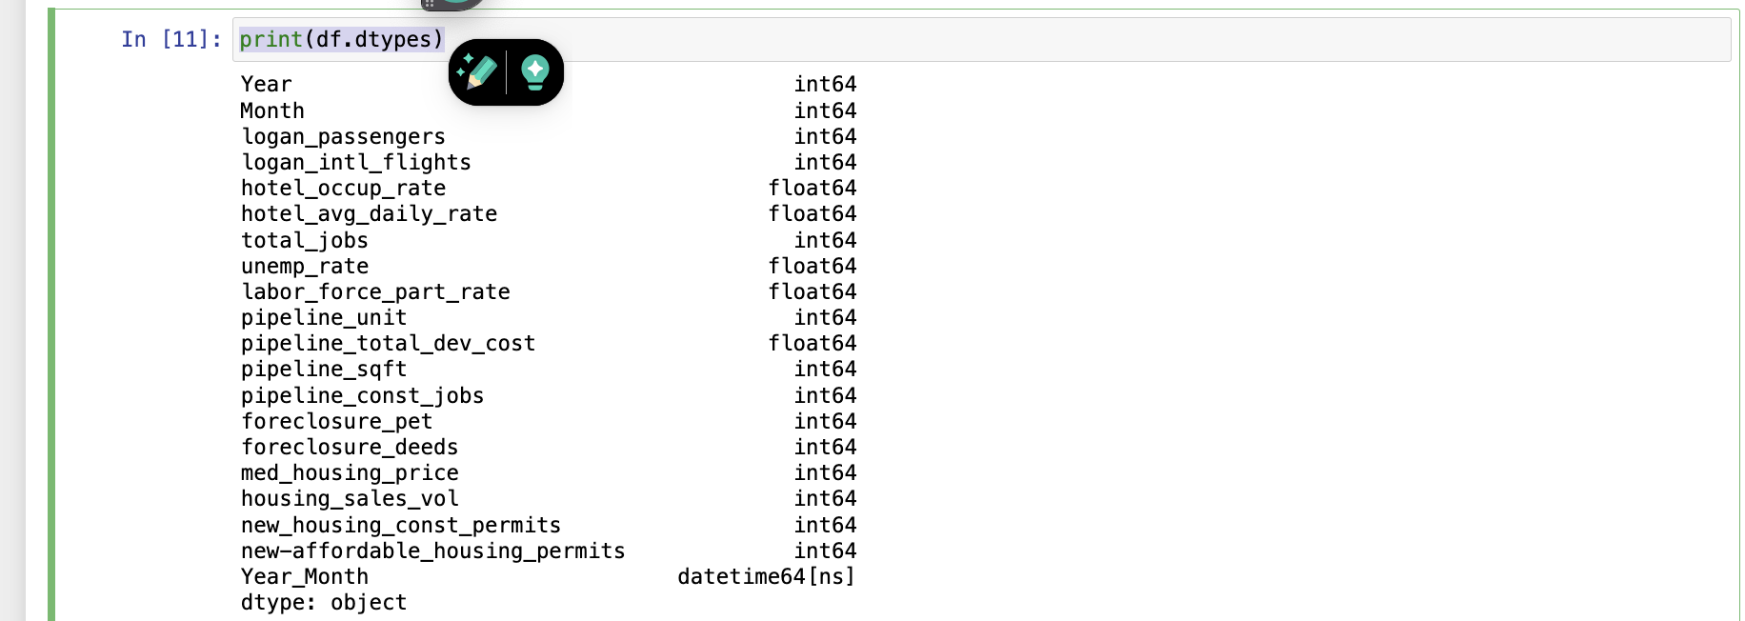

corr=df.corr()

sns.heatmap(corr)

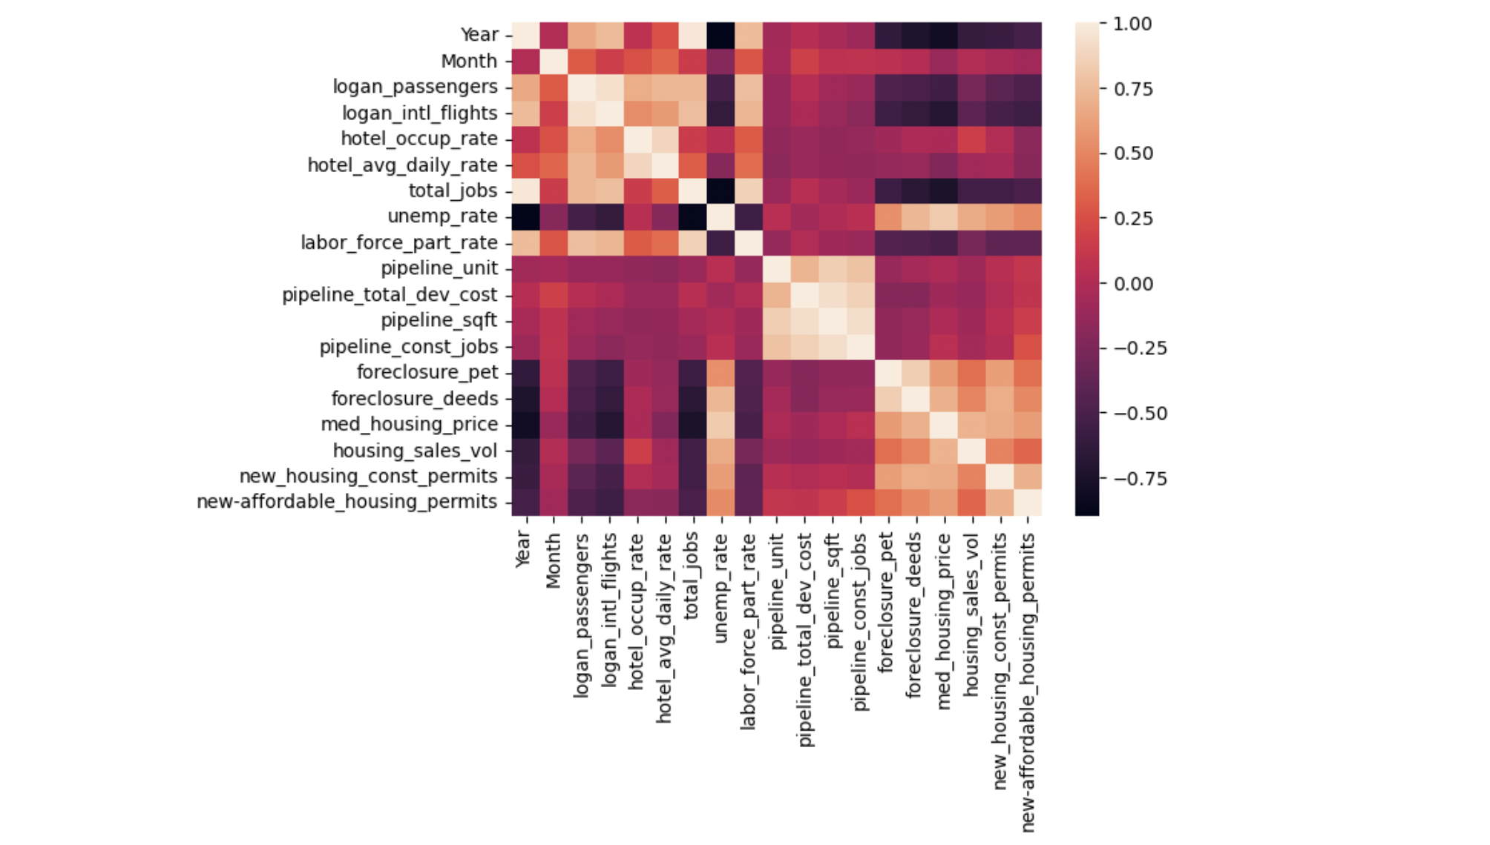

df.corr()



#sns.pairplot(df)

basic_stats = df.describe()

columns_to_exclude = ['Year_Month', 'Year', 'Month', ] # Replace with your actual column names

columns_to_plot = [col for col in df.columns if col not in columns_to_exclude]

for col in columns_to_plot:

fig = px.histogram(df, x=col, nbins=20, title=f'Histogram of {col}', color="Year")

fig.show()

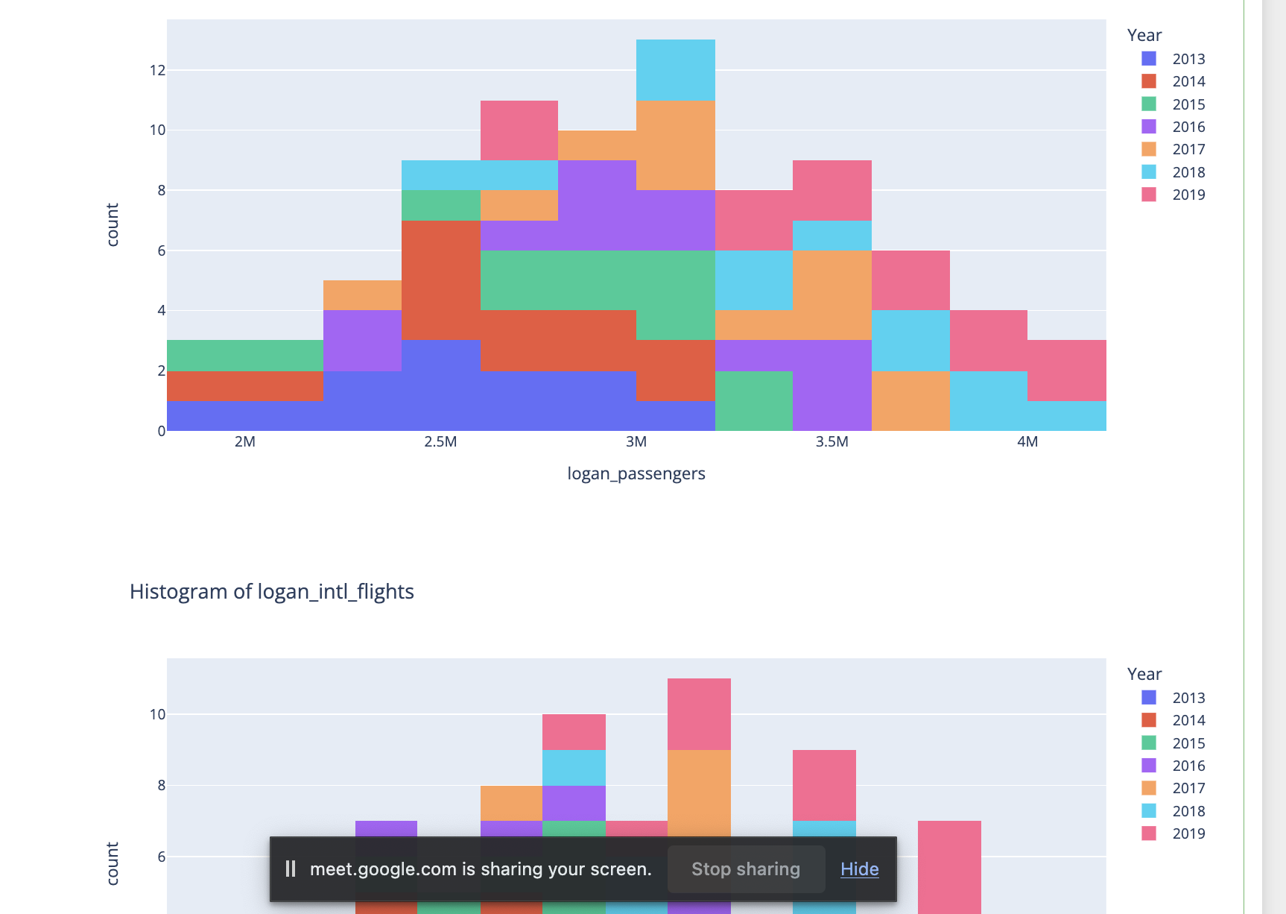

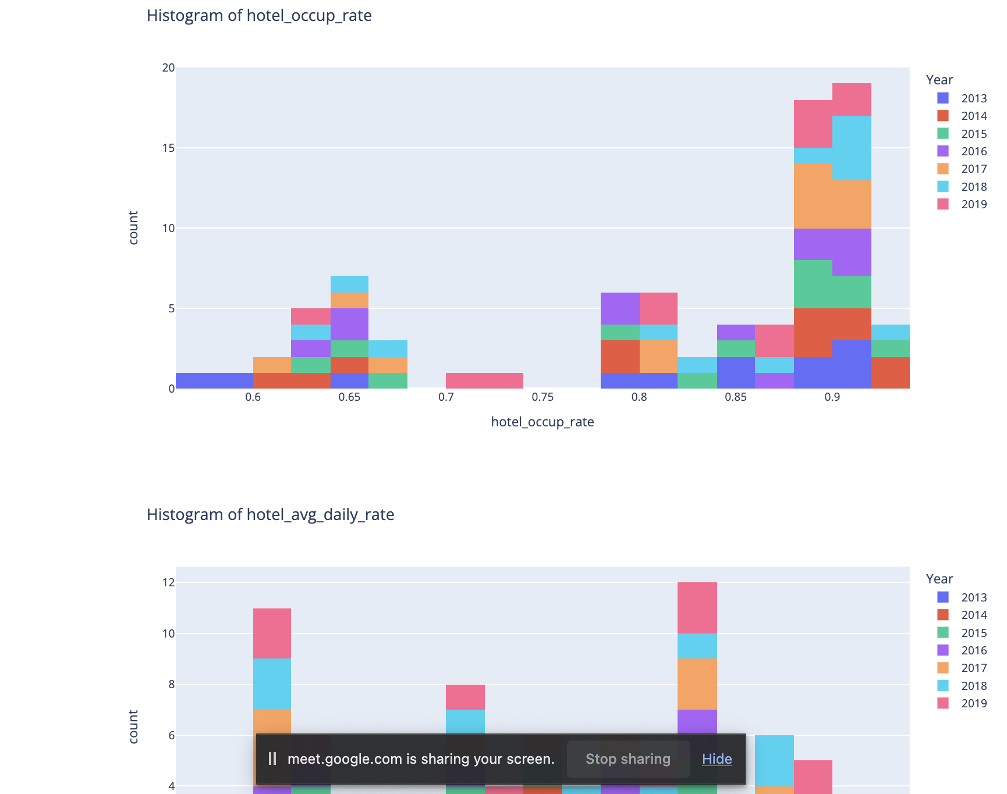

#for column in df.columns:

# fig = px.histogram(df, x=column, nbins=20, title=f'Histogram of {column}', color="Year")

# fig.show()

print(basic_stats)



sns.set(style="whitegrid")

plt.figure(figsize=(10, 6))

sns.heatmap(basic_stats.transpose(), annot=True, cmap="YlGnBu", fmt=".2f", linewidths=0.5)

plt.title('Summary Statistics')

plt.show()

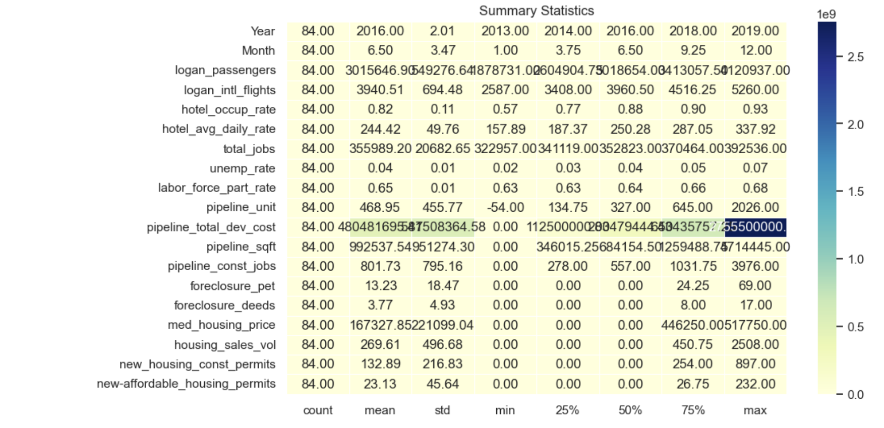

columns_to_plot = [col for col in df.columns if col not in columns_to_exclude]

for col in columns_to_plot:

fig = px.line(df, x='Year_Month', y=col, labels={col: f'{col} Value'})

fig.update_layout(

xaxis_title='Year_Month',

yaxis_title='Value',

title=f'Time Series Plot of {col}',

)

fig.show()











target_variable = 'total_jobs'

# Select variables with strong correlations (you can customize this based on your correlation table)

correlated_variables = ['logan_passengers', 'logan_intl_flights', 'hotel_occup_rate', 'hotel_avg_daily_rate', 'unemp_rate', 'labor_force_part_rate']

# Create scatter plots for each correlated variable

for var in correlated_variables:

fig = px.scatter(df, x=var, y=target_variable, title=f'Scatter Plot of {var} vs {target_variable}', labels={var: var, target_variable: target_variable})

fig.show()







from sklearn.model_selection import train_test_split

from sklearn.linear_model import LinearRegression

from sklearn.metrics import mean_squared_error

from sklearn.preprocessing import StandardScaler

columns_to_drop = ['Year', 'Month', 'pipeline_unit', 'pipeline_total_dev_cost', 'pipeline_sqft',

'pipeline_const_jobs', 'foreclosure_pet', 'foreclosure_deeds', 'med_housing_price',

'housing_sales_vol', 'new_housing_const_permits', 'new-affordable_housing_permits','Year_Month','hotel_occup_rate', 'hotel_avg_daily_rate']

df = df.drop(columns=columns_to_drop)

features = ['logan_passengers', 'logan_intl_flights', 'unemp_rate', 'labor_force_part_rate']

target = 'total_jobs'

data = df.dropna(subset=features + [target])

data

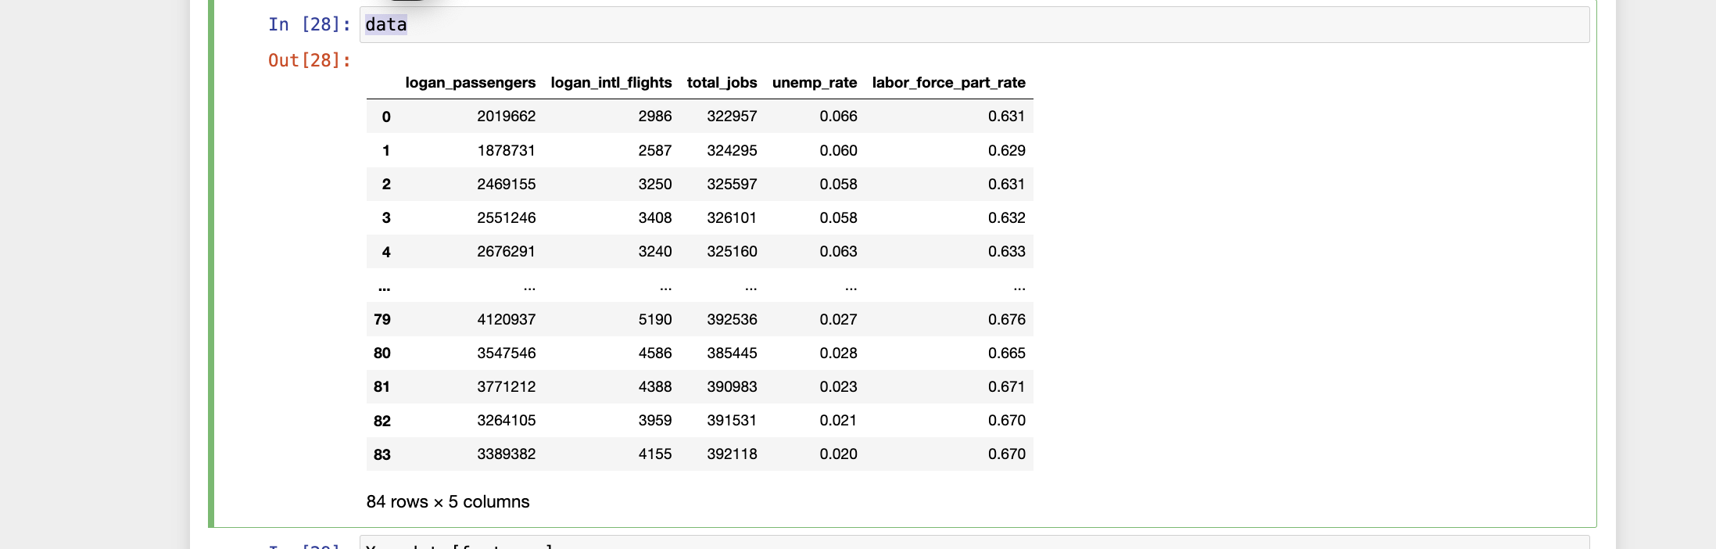

import matplotlib.pyplot as plt

# Assuming you have the actual values (y_test) and predicted values (y_pred)

# Replace y_test and y_pred with your actual and predicted values

plt.scatter(y_test, y_pred)

plt.plot([min(y_test), max(y_test)], [min(y_test), max(y_test)], linestyle='--', color='red', linewidth=2) # Diagonal line for reference

plt.xlabel('Actual Total Jobs')

plt.ylabel('Predicted Total Jobs')

plt.title('Predicted vs. Actual Total Jobs')

plt.show()



import matplotlib.pyplot as plt

import seaborn as sns

# Calculate residuals

residuals = y - predictions

# Plot histogram of residuals

plt.figure(figsize=(8, 6))

sns.histplot(residuals, kde=True)

plt.title('Histogram of Residuals')

plt.xlabel('Residuals')

plt.ylabel('Frequency')

plt.show()

# Scatter plot of residuals against predicted values

plt.figure(figsize=(8, 6))

sns.scatterplot(x=predictions, y=residuals)

plt.axhline(y=0, color='r', linestyle='--', linewidth=2)

plt.title('Residuals vs. Predicted Values')

plt.xlabel('Predicted Values')

plt.ylabel('Residuals')

plt.show()





Data

